**EXPERIMENT-5**

Name: K.Sriya

Roll No: 2320090043

**Aim :** Configuration of Encapsulation dot 1Q using cisco packet tracerNeed for VLANs and Dot1Q Encapsulation

**Apparatus Required:** Two 3560 switches and 4 PCs, copper straight-through cables.

# Procedure:

**Step 1:** Open Cisco Packet Tracer.

**Step 2:** Drag one 3560 switch 1, connect two PCs to it, next drag 3560 switch 2 and connect two PCs to it by using straight-through cables.

**Step 3:** Configure VLANs on the switch using some commands.

**Step 4:** Configure VLANs on both switches through click on the switch, go to CLI tab.

**Step 5:** Give IP addresses on PCs.

**Step 6:** Verify configuration, check VLANs on the switch.

**Step 7:** Check trunk ports.

**Step 8:** Test connectivity, ping PC1 to PC2.

# Result:

Configure VLANs on Switch 1 and 2: enable

configure terminal vlan 10

name sales exit

vlan 20

name product exit

interface FastEthernet0/1 switchport mode access switchport access vlan 10 exit

interface FastEthernet0/2 switchport mode access switchport access vlan 20 exit

interface FastEthernet0/3

switchport trunk encapsulation dot1q switchport mode trunk

exit

# Assign IP Addresses to PCs:

* PC1 - IP address: 192.168.1.2
* PC2 - IP address: 192.168.2.2
* PC3 - IP address: 192.168.1.3
* PC4 - IP address: 192.168.2.3

# Verify Configuration:

Check VLANs on the Switch: show vlan brief

# VLAN NAME

1 default

2 default fa0/3, fa0/4 fa0/8, fa0/9

fa0/12, fa0/13, fa0/14 fa0/16, fa0/17, fa0/18 fa0/20, fa0/21, fa0/22 fa0/24, Gig0/1, Gig0/2

# VLAN 2

1002 - fddi - default

1003 - token-ring - default 1004 - fddinet - default 1005 - trnet - default

# show interfaces trunk

|  |  |  |  |  |
| --- | --- | --- | --- | --- |
| **Port** | **Mode** | **Encapsulation** | **Status** | **Native VLAN** |
| fa0/10 | On | 802.1q | trunking | 1 |

**Vlans allowed on trunk**

1-1005

# Vlans allowed and active in management domain

1, 2

# Vlans in spanning tree forwarding state and not

1, 2

# Ping PC1 to PC2

Ping 192.168.1.2

Configure Vlan on Swtiches

Switch 2 (here I have took switch 1 as switch 2)

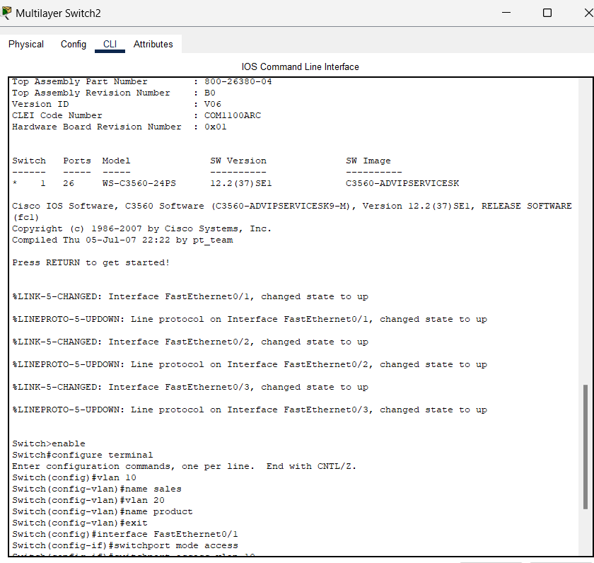

Switch 3 (here I have took switch 2 as switch switch 3)

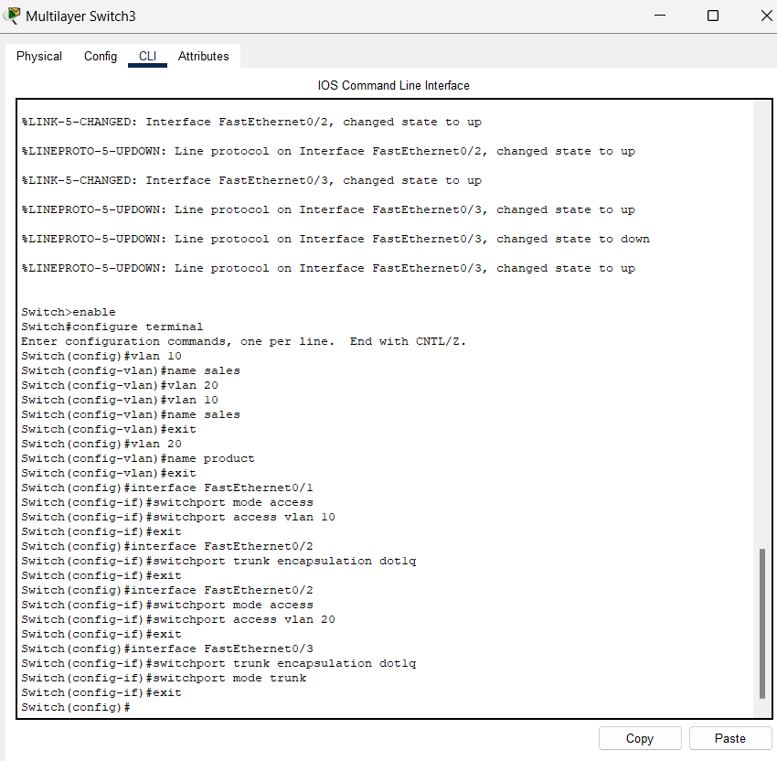

# Assign IP Addresses to PCs

For pc0

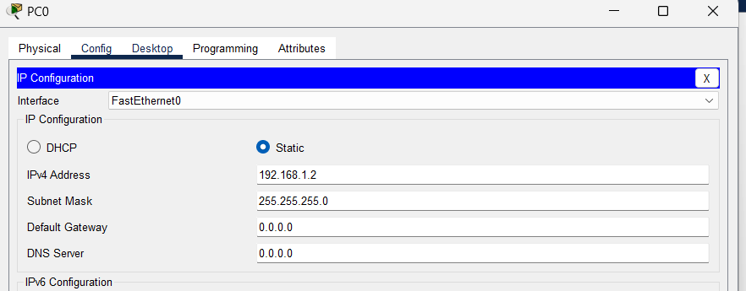

For pc1

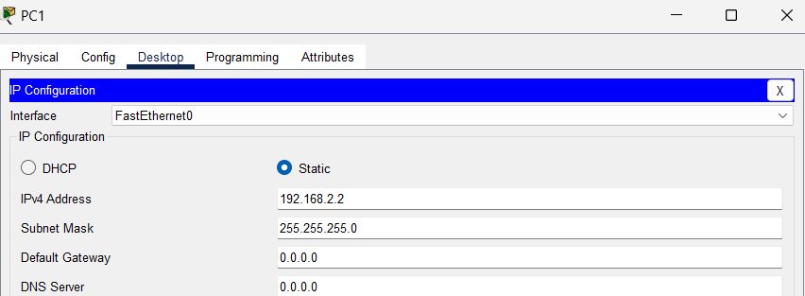

For pc 2

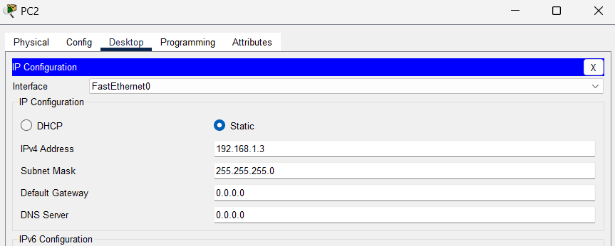

For pc3

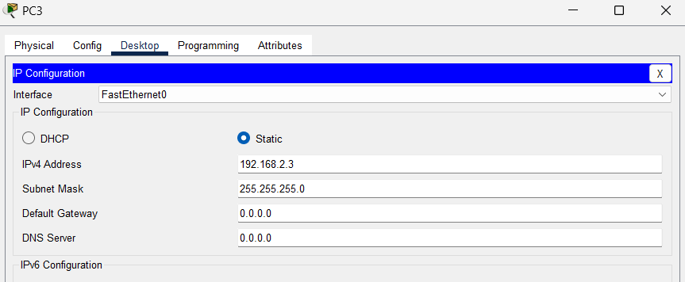

**Verify Configuration**

1. **Check VLANs on the Switch**:

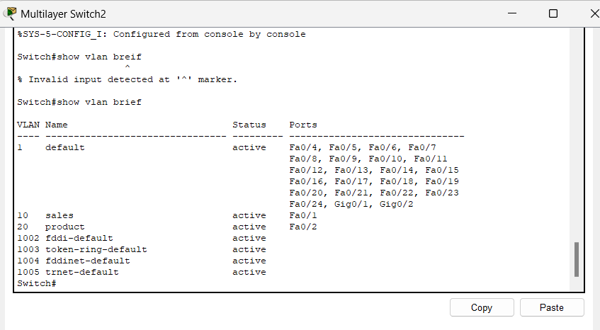

**Check Trunk Ports**

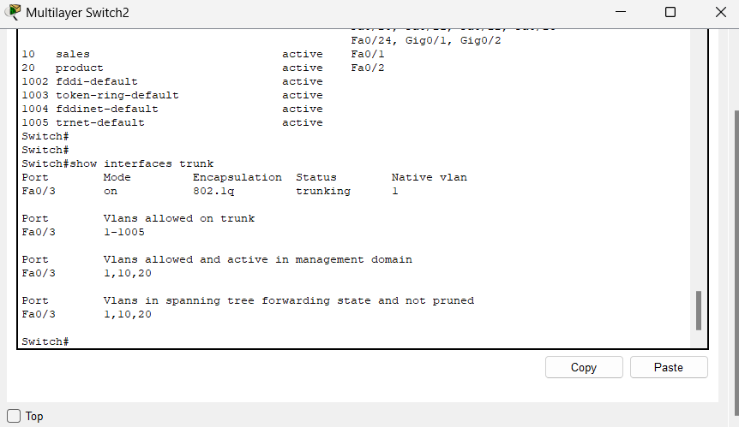

**Test Connectivity**:

